



**Direct Absorbance Bilirubin Spectrometer (DABS)**

*Divide and Conquer version 2.0*



Bernardin Dezius, CpE

Juan Gonzalez, EE

Kevin Kuzius, EE

Kevin Landau, PSE

Andrea Wetteland, PSE



*Department of Electrical and Computer Engineering*

*And*

*The College of Optics and Photonics*

# Narrative

## Motivation

Neonatal hyperbilirubinemia, or jaundice, is a common condition in newborns wherein elevated concentrations of bilirubin causes yellow discoloration of the skin and eye whites. Bilirubin is the product of hemoglobin being broken down. When the neonate liver is incapable of processing the bilirubin because of increased production, decreased excretion, or other impaired mechanic, an excess concentration can occur. Levels resulting in visible discoloration occur in almost 60% of all neonates. At higher levels (308 μmol/L), the bilirubin is toxic to the neonate brain, and encephalopathy or brain damage (kernicterus) can occur without treatment. For less extreme cases, sunlight exposure is sufficient to aid the neonate in processing bilirubin. Phototherapy treatment is successful in treating hyperbilirubinemia in most extreme cases, therefore the key issues timely diagnosis and treatment.

Bilirubin concentration levels usually rise to dangerous levels 3-4 days after birth. Unfortunately, many infants and mothers are discharged from hospitals 2 days after birth, so hyperbilirubinemia is often not detected until the first pediatric checkup, often 5-7 days after birth. Due to the commonality of neonatal jaundice, many parents noticing the yellow discoloration in infants are advised by doulas and internet searches not to worry, or to just keep the baby near a window to provide sunlight exposure. This means more serious cases of hyperbilirubinemia can go undiagnosed for days. This project aims to allow new parents to test neonate bilirubin concentrations from home, offering peace of mind for mild cases, and earlier detection for more severe cases.

## Goals and Objectives

The Direct Absorbance Bilirubin Spectrometer (DABS) will make it possible to get an accurate bilirubin concentration from the home. The goal is to measure 100% of samples with 90% or greater accuracy. Greater sample accuracy is not necessary, as the purpose is to alert parents as to whether the infant should be taken to the hospital for more accurate testing. In order for our device to have the value of in-home convenience, the device must have a simple interface that a person with a non-scientific background can operate. Most persons with a non-medical background will not be comfortable withdrawing large amounts of blood from a newborn, so the required sample size must be small enough to be obtained with a pinprick. The device must also be smaller than a breadbox and lightweight, for ease of use and to reduce the burden of shipping costs to the user. Because a major purpose of the device is to offer early detection by a few days, it would not make sense for parents to purchase a device after they already suspect elevated bilirubin levels. The device must be affordable, so that it is not prohibitive for most parents to preemptively purchase or borrow a device before birth.

## Functionality

Bilirubin is yellowish-orange and absorbs light at 440 nm. Hemoglobin also absorbs light at 440 nm, but absorbs light at 528 nm in equal measure. The DABS will shine a sources of light, at ~550 nm, through a cuvette and use a photodiode array to measure the transmitted intensity of the wavelength. The absorbance of each wavelength will be calculated with Beer’s Law. By using a clean control sample as a reference sample, the resulting relative change in current detected by the photodiode through the bilirubin sample and corresponding circuit will provide a bilirubin concentration.

One of the most common techniques to measure bilirubin concentration in serum or plasma is the “Diazo” method. This method involves using various diazo dyes in the presence of an accelerating agent into a coupling reaction to have conjugated bilirubin which is water soluble. The results of this method are limited by sample hemolysis as well as the concentration of hemoglobin and bilirubin in the sample.

Direct spectrophotometric and diazo methods are only effective to measure bilirubin in neonates younger than 2 to 3 weeks old since other pigments such as carotenoids start to develop and also absorb at 454 nm. Once the neonates’ age is past the 2 to 3 week mark another method known as HPLC or High Performance Liquid Chromatography can be performed. This chemical method is not subject to interference from hemoglobin or lipemia but it is very labor intensive and impractical for routine use.

# Specifications

|  |  |
| --- | --- |
| Specification | Description |
| USB | USB must supply at least 5 Volts for device usage |
| Battery Life | Device must last greater than 1 hour of continuous use |
| Light Source | 50 mW green laser and blue laser diode  Collimating lens with ~1 cm focal length |
| Dimensions | The device should measure no more than  13 x 8 x 5" |
|  |  |
| PCB | PCB should be < 12 x 12 cm |
| Optical Filtering | Detect 550 nm and 460 nm wavelengths |
| Sample Size | Blood sample size must be 0.4 - 0.6 mL |
| Optical Sensing Accuracy | +90 % Accurate detection |
| Weight | The device should weigh < 50 lbs |
| Runtime | Testing of sample should last no longer than 10 minutes |
| Cooling system | Device should be maintained at room temperature (25 ℃ ± 5%) |
| Cost | This device should cost less than $1000 |

## 

# Block Diagram

# 



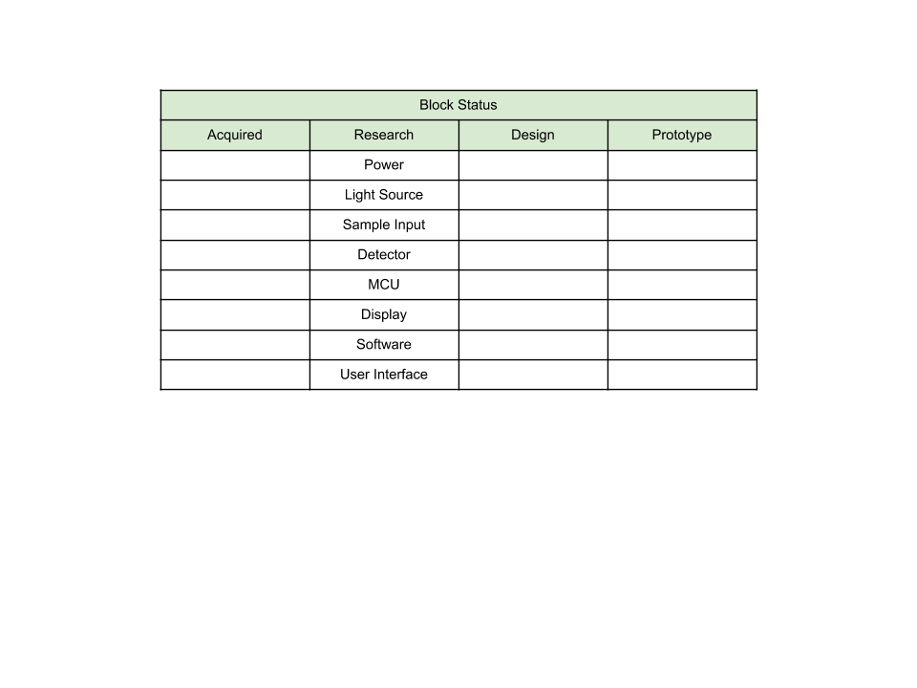



# Block Descriptions

## User Interface (Display)

The display will take in and output the values and information associated with before and after the analysis, respectively. At the start of a fresh analysis the display will illustrate a way to begin the process as well as input any specific data that is needed for this specific patient. And once the analysis is complete the display will transition to illustrate the results of the analysis as well as recommendations. Such as, whether to consult a medical professional.

## Power Supply

The power supply will discharge a constant voltage as to operate every module such that they operate within a comfortable functionality range. User will have the option of operating the device via USB connection as well.

## Optical Source

A 50 mW green laser diode, with voltage needs of ~4V will produce ample intensity to obtain a valid reading at 550 nm. A collimating lens will be used to collimate the light before reaching the sample in order to maximize efficiency.

## Sample Input

Obtaining and using neonate blood may prove to have insurmountable hurdles. A proxy blood sample with comparable absorbance spectra may need to be used in testing the proof of concept. We plan on contacting Dr. Dogariu for options. Research is needed to determine whether using a whole blood sample is feasible, or if a coagulated or otherwise specially prepared sample will be needed.

We will use a total bilirubin reagent set to stain the bilirubin to take an absorbance reading at 550 nm. This set can be purchased from Pointe Scientific and consists of a working reagent, composed of sulfanilic acid, hydrochloric acid, and dimethyl sulfoxide, and a sodium nitrate reagent. This will create a diazo that will bond with the bilirubin present.

For proof-of-concept, a saline solution with a commercially-available synthetic bilirubin, ditaurobilirubin (DTB) disodium salt, added in known concentrations will be used for testing.

## Detection

For detection, the goal is to be able to pick up the spectrum of 550 nm in the blood of neonates (infants, 2-3 weeks old).

## MCU

The processing unit is responsible for all analysis and coordinating. The list of tasks it should be able to complete consist of:

* Being able to consistently detect the signs of the disease, i.e. specific range of wavelengths
* Applying the appropriate filtering for both bilirubin and hemoglobin
* Convert signals inputted and exported to be readable by the end-recipient.
* Display a user-friendly result, via reliable communication protocol

The PCB will be designed with size and cost considerations in mind, to be useful for an in home test station.

# Cooling System

The cooling system will keep the components and testing sample in a controlled temperature range of 77 °F ± 5% for the duration of the test.

# Budget

# 

|  |  |  |  |
| --- | --- | --- | --- |
| **Item** | **Cost** | **Quantity** | **Total Cost** |
| MCU | $30 | 1 | $30 |
| Power supply | $50 | 1 | $50 |
| Light source | $20 | 1 | $20 |
| Synthetic Bilirubin | $56 | 25mg | $56 |
| breadboard | 10 | 1 | $10 |
| Detector | $50 | 1 | $50 |
| Temperature sensor | $15 | 1 | $15 |
| Fans | $5 | 2 | $10 |
| Miscellaneous Electrical components | < $50 | various | <$50 |
| Display | $100 | 1 | $100 |
| PCB | $50 | 2 | $100 |
| **FINAL COST** | | | **~ $ 650** |

Table 1. Cost estimation for project.

# Milestones

Senior Design Ⅰ - Fall 2019

|  |  |  |
| --- | --- | --- |
| **Task Description** | **Duration** | **Date** |
| Project idea brainstorming | 2 weeks | Aug. 26 - Sep. 9 |
| Rough draft of Initial project documentation | 10 days | Sep. 9 - Sep. 19 |
| **Submittal of initial project documentation v.1** | | **Sep. 20** |
| Individual research | 2 weeks | Sep. 16 - Sep.30 |
| **Submittal of initial project documentation v.2** | | **Oct. 4** |
| Design and integration discussion/collaboration | 3 weeks | Sep. 30 - Oct 21 |
| Documentation draft | 3 weeks | Oct. 7 - Oct. 28 |
| **Submittal of 60 page draft** | | **Nov. 1** |
| Procurement of components/equipment | 3 weeks | Oct. 7 - Oct. 28 |
| Research and additional design | 2 weeks | Nov. 4 - Nov. 18 |
| Additional documentation | 1 week & 6 days | Nov. 2 - Nov. 14 |
| **Submittal of 100 page draft** | | **Nov. 15** |
| Component testing | 5 weeks | Oct. 28 - Dec. 2 |
| Design finalization and additional documentation | 2 weeks | Nov. 18 - Dec. 2 |
| **Submittal of Final Senior Design 1 documentation** | | **Dec. 2** |

Table 2. Expected milestone for 1st semester.

Senior Design Ⅱ - Spring 2020

|  |  |  |
| --- | --- | --- |
| **Task Description** | **Duration** | **Date** |
| Initial prototype build | 4 weeks | Dec. 2 - Dec. 30 |
| Prototype construction | 1 week | Dec. 30 - Jan. 6 |
| Test components and outputs | 1 week | Jan. 6 - Jan. 13 |
| Software and design testing | 3 weeks | Jan. 13 - Feb. 3 |
| Prototype hardware integration | 6 weeks | Jan. 13 - Feb. 24 |
| Preparation and testing for midterm demo | 2 weeks | Feb. 24 - Mar. 9 |
| **Midterm demo** | | **3/13** |
| Final product integration | 4 weeks | Mar. 9 - Apr. 6 |
| Final product testing and preparation for final presentation | 1 week | Apr. 6 - Apr. 13 |
| Additional documentation | 2 weeks | Apr. 6 - Apr. 20 |
| **Final presentation and demo** | | **4/16** |

Table 3. Expected milestone for 2nd semester.

## Citations

1. Steven C. Kazmierczak, Alex F. Robertson, Paul G. Catrou, Kimberly P. Briley, Bill L. Kreamer, Glenn R. Gourley. “Direct Spectrophotometric Method for Measurement of Bilirubin in Newborns: Comparison with HPLC and an Automated Diazo Method”. Clinical Chemistry Jul 2002, 48 (7) 1096-1097.
2. Suzuki, Yuji. (2000). Chemical characteristics of ditaurobilirubin as a substitute product of serum bilirubin. BUNSEKI KAGAKU. 49. 901-905. 10.2116/bunsekikagaku.49.901.

## 